2015

The quadrotor is very well modelled with four rotors in a cross or plus configuration.This plus structure is quite thin and light, however it shows robustness by linking mechanically the motors (which are heavier than the structure). Each propeller is connected to the motor through the reduction gears. All the propellers axes of rotation are fixed and parallel. Furthermore, they have fixed-pitch blades and their air flow points downwards (to get an upward lift). These considerations point out that the structure is quite rigid and the only things that can vary are the propeller speeds.
In this section, neither the motors nor the reduction gears are fundamental, because the movements are directly related just to the propellers velocities. The others parts will be taken into account in the following sections. Another neglected component is the electronic box. As in the previous case, the electronic box is not essential to understand how the quadrotor flies. It follows that the basic model to evaluate the quadrotor movements it is composed just of a thin cross structure with four propellers on its ends.
The front and the rear propellers rotate counter-clockwise, while the left andthe right ones turn clockwise. This configuration of opposite pair directions removesthe need for a tail rotor (needed instead in the standard helicopter structure).

Figure.1 shows the structure model in hovering condition, where all the propellers have the same speed.

Figure.1: Simplified quadrotor motor in hovering

In Figure 1 a sketch of the quadrotor structure is presented in black. Thefixed-body B-frame is shown in green and in blue is represented the angular speed of the propellers. In addition to the name of the velocity variable, for each propeller,two arrows are drawn: the curved one represents the direction of rotation, the other one represents the velocity. This last vector always points upwardshence it doesn’t follow the right hand rule (for clockwise rotation) because it alsomodels a vertical thrust and it would be confusing to have two speed vectorspointing upwards and the other two pointing downwards.In the model of figure 3.1 all the propellers rotate at the same (hovering)speed ῼH [rad s−1] to counterbalance the acceleration due to gravity. Thus, thequadrotor performs stationary flight and no forces or torques move it from itsposition.

Even though the quadrotor has 6 DOF, it is equipped just with four propellers,hence it is not possible to reach a desired set-point for all the DOF, but atmaximum four. However, thanks to its structure, it is quite easy to choose thefour best controllable variables and to decouple them to make the controllereasier. The four quadrotor targets are thus related to the four basic movementswhich allow the helicopter to reach a certain height and attitude. It follows thedescription of these basic movements:

• Throttle
This command is provided by increasing (or decreasing) all the propellerspeeds by the same amount. It leads to a vertical force with respect to body-fixedframe which raises or lowers the quadrotor. If the helicopter is in horizontalposition, the vertical direction of the inertial frame and that one of thebody-fixed frame coincide. Otherwise the provided thrust generates bothvertical and horizontal accelerations in the inertial frame.

Figure.2: Throttle movement

In blue it is specified the speed of the propellers which, in this case, is equal to ῼH + ΔA for each one. ΔA [rad s−1] is a positive variable which represents an increment respect of the constant ῼH. ΔA can’t be too large because the model would eventually be influenced by strong non linearities or saturations.

• Roll
This command is provided by increasing (or decreasing) the left propeller speed and by decreasing (or increasing) the right one. It leads to a torque with respect to the xB axis which makes the quadrotor turn. The overall vertical thrust is the same as in hovering, hence this command leads onlyto a roll angle acceleration (in first approximation).
Figure.3: Roll movement

The positive variables ΔA and ΔB [rad s−1] are chosen to maintain the vertical thrust unchanged. It can be demonstrated that for small values of ΔA, ΔB≈ΔA. As in the previous case, they can’t be too large because the model would eventually be influenced by strong non linearities or saturations.

• Pitch
This command is very similar to the roll and is provided by increasing (or decreasing) the rear propeller speed and by decreasing (or increasing) the front one. It leads to a torque with respect to the yB axis which makes the quadrotor turn. The overall vertical thrust is the same as in hovering, hence this command leads only to a pitch angle acceleration (in first approximation).

Figure.4: Pitch movement

As in the previous case, the positive variables ΔA and ΔB are chosen to maintain the vertical thrust unchanged and they can’t be too large. Furthermore, for small values of ΔA, it occurs ΔB≈ΔA.

• Yaw
This command is provided by increasing (or decreasing) the front-rear propellers’speed and by decreasing (or increasing) that of the left-right couple.It leads to a torque with respect to the zB axis which makes the quadrotorturn. The yaw movement is generated thanks to the fact that the left-rightpropellers rotate clockwise while the front-rear ones rotate counterclockwise.Hence, when the overall torque is unbalanced, the helicopter turns on itselfaround zB. The total vertical thrust is the same as in hovering, hence this
command leads only to a yaw angle acceleration (in first approximation).Figure.5 shows the yaw command on a quadrotor sketch.

Figure.5: Yaw movement

As in the previous two cases, the positive variables ΔA and ΔB are chosen to maintain
the vertical thrust unchanged and they can’t be too large. Furthermore it
maintains the equivalence ΔB ≈ ΔA for small values of ΔA.

- Mathematical Model

2.1 Introduction
Before jumping into the mathematic model, some discussion of notation is needed. Due to the complexity of a system with 6 degrees of freedom, various methods of notation have been developed and are required in order to sufficiently describe the critical variables. Shown below is an example of the notation we have chosen:
${}_{}^{b}{{\overset{´}{v}}_{CM∨i}^{b}}$
Here, the base variable is linear acceleration, or $\overset{´}{v}$. As you can see, the variable also has two superscripts and one subscript to further delineate what we are describing. The top left superscript, b, tells us that the derivative taken was performed in the body frame of reference, while the top right superscript, $b$, tells us that the acceleration is given in terms of body frame vector components, and the subscript, $CM∨i$, tells us that this variable is referencing the center of mass with respect to the inertial frame.
Another important aspect of the math model is the coordinate system that is used. The chosen model and conventions will become very important as you work through your model, so be sure to keep your decisions in mind and clearly documented. The coordinate system will vary whether you use a plus (“+”) or “X” configuration.

The plus configuration we use is defined as having the X axis lie along the arm of motor 1 (which spins counter-clockwise from above, by our convention) with the Y axis set along the arm of motor 2 (spinning in the opposite direction of the adjacent motors) and the Z axis pointing upward. The value $d$ represents the distance from a given motor to the axis of rotation, and should be the same for every motor. This value will change if using an x configuration, which is defined as a rotation in the X-Y plane of 45 degrees in the positive yaw direction, which results in having the X axis lie between motor 1 and 2. In either configuration the x axis is assumed to be the positive forward direction for vehicle movement.

2.2 Mass Moment of Inertia Matrix
One element of the system of importance is the inertia matrix. The inertia matrix describes the quadcopters mass moment of inertia across the defined axes, and is important to the flight dynamics of the system. With some approximations, you can determine the mass moment of inertia across the X, Y, and Z axes in order to populate the required inertia matrix. This particular process is covered in more detail in the Mass Moment of Inertia documentation. Once determined using either the “+” or “X” configuration, the inertia matrix will appear as follows:
$J^{b}=\left[\begin{matrix}J_{xx} & 0 & 0 \\ 0 & J_{yy} & 0 \\ 0 & 0 & J_{zz}\end{matrix}\right]$ (Mass Moment of Inertia Matrix)

Here, $J^{b}$ is the inertia of the quadcopter relative to the body frame with $J_{xx}$, $J_{yy}$, and $J_{zz}$ being the inertia of the quadcopter across each axis. Due to the symmetry of the system, the matrix is diagonal and will be identical for either a “+” or “X” configuration. The diagonal form of the matrix is convenient due to the need to invert the matrix for use in the angular velocity state equation.

Thrust Coefficient
The motors' thrust is the driving force behind all quadcopter maneuvers and thus is integral to control design and simulation. The thrust,$T$, provided by a single motor/prop system can be calculated as follows:
$T=C_{T}ρA_{r}r^{2}ϖ^{2}$
Where $C_{T}$ is the thrust coefficient for a specific rotor, $ρ$ is the density of air, $A_{r}$ is the cross sectional area of the propeller's rotation, $r^{}$is the radius of the rotor, and $ϖ$ is the angular velocity of the rotor. For simple flight modeling a lumped parameter approach can be used to simplify the characterization process:
$T=c_{T}ϖ^{2}$ (Thrust Coefficient Relation)
Here $c_{T}$ is the lumped parameter thrust coefficient that pertains to the individual motor/prop system. The thrust provided by the motor/prop provides a force perpendicular to the X-Y plane of the body frame in the positive Z direction.

Torque Coefficient
In order to understand motor effect on yaw, the torque force of the motor/prop system must also be determined, and can be done in a similar fashion to that of the thrust tests. The related lumped parameter equation is shown below:
$Q=c_{Q}ϖ^{2}$ (Torque Coefficient Relation)
In this case, $Q$ is the torque created by the motor and $c_{Q}$ is the torque coefficient for the motor/prop system. This torque provides a force that acts to yaw the system about the z-axis.

2.3 Initial Matrix Construction
After performing a range of tests with each of the test stands, the provided data analysis programs can help you calculate these coefficients for characterizing your system. With this information we can create a matrix describing the thrusts and torques on the system like that shown below:
$\begin{aligned}c_{T} \\ c_{T} \\ c_{T} \\ c_{T} \\ 0 \\ T \\ d_{}0 \\ T \\ \left[\begin{aligned}\begin{matrix}ΣT \\ τ_{ϕ}\end{matrix} \\ \begin{matrix}τ_{θ} \\ τ_{ψ}\end{matrix}\end{aligned}\right]=\left[\begin{matrix}T & d_{}0 & T & d_{}0 \\ −d_{}−{−c}_{Q} & c_{Q} & {−c}_{Q} & c_{Q}\end{matrix}\right]\left[\begin{matrix}ϖ_{1}^{2} \\ ϖ_{2}^{2} \\ ϖ_{3}^{2} \\ ϖ_{4}^{2}\end{matrix}\right]\end{aligned}$ (“+” configuration)
All of the present values have been explained thus far except for $d_{}$, which is simply the distance between the motors and the respective axes of rotation, where $\begin{aligned}+ \\ d_{}\end{aligned}$ is the arm length from quadcopter hub center to motor/prop.
If using an x configuration, $d_{x}$ can instead be found by $\begin{aligned}+sin\left(45\right) \\ d_{}\end{aligned}$, as that would be the value for the distance between the motor/prop and the body's axes of rotation. Thus, $c_{Q}$ experiences no change from this configuration adjustment, while the effect of $c_{T}$ will be distributed across all four motors for both pitch and roll.
$\left[\begin{aligned}\begin{matrix}ΣT \\ τ_{ϕ}\end{matrix} \\ \begin{matrix}τ_{θ} \\ τ_{ψ}\end{matrix}\end{aligned}\right]=\left[\begin{matrix}c_{T} & c_{T} & c_{T} & c_{T} \\ −{d_{x}c}_{T} & {d_{x}c}_{T} & {d_{x}c}_{T} & {−d_{x}c}_{T} \\ −{d_{x}c}_{T} & −{d_{x}c}_{T} & {d_{x}c}_{T} & {d_{x}c}_{T} \\ {−c}_{Q} & c_{Q} & {−c}_{Q} & c_{Q}\end{matrix}\right]\left[\begin{matrix}ϖ_{1}^{2} \\ ϖ_{2}^{2} \\ ϖ_{3}^{2} \\ ϖ_{4}^{2}\end{matrix}\right]$ (“X” configuration)

Throttle Command Relation
An important consideration here for control purposes is that the coefficients of thrust and torque are based on a relationship with RPM of the motors and not something directly determined by the control system (such as throttle command). Due to this, a linear regression is needed that will translate throttle command values (as percent throttle) to RPM values. The following regression was created for this purpose:
$ϖ_{ss}=\left(Throttle\right)c_{R}+b$
Here $ϖ_{ss}$ is the expected steady-state motor RPM, $Throttle$ is the throttle percentage command, $c_{R}$ is the throttle % to RPM conversion coefficient, and $b$ is the y-intercept of the linear regression relationship. The linear regression can be performed using the provided data analysis program, which allows your controller to use the proper coefficients as determined by your motor testing for maximum accuracy and realism.

Gyroscopic Forces
There is one more set of forces to account for before we create our moment matrix, and those are the forces resulting from gyroscopic precession. Gyroscopic precession is a phenomenon that occurs when the axis of rotation of a rotating body is changed, and the results are typically non-intuitive to those unfamiliar with its effects. The gyroscopic forces resulting on the body are governed by the inertia of each motor’s rotating components ($J_{m}$), the rolling and pitching rates ($P$ and $Q$), as well as the speed of each motor/prop system ($ϖ_{i}$). The gyroscopic torques created by the motors for pitch and roll action are shown below:
$τ_{ϕ_{gyro}}=J_{m}Q\left(\frac{π}{30}\right)\left(ϖ_{1}−ϖ_{2}+ϖ_{3}−ϖ_{4}\right)$
$τ_{θ_{gyro}}=J_{m}P\left(\frac{π}{30}\right)\left(−ϖ_{1}+ϖ_{2}−ϖ_{3}+ϖ_{4}\right)$
The π/30 term corresponds to the transition from RPM to radians that must occur for the gyroscopic force to be calculated.

2.4 Final Matrix Construction
With these motor/prop forces added in to the appropriate terms we can again organize the equations in matrix form for our simulation purposes. The resulting matrix will account for the mentioned aerodynamic, gyroscopic, and thrust moments created by the motor/prop systems on the quadcopter for a "+" configuration:
$\begin{aligned}T \\ T \\ {d_{}ϖ}_{2}^{2}{−d_{}ϖ}_{4}^{2}+J_{m}Q\left(\frac{π}{30}\right)\left(ϖ_{1}−ϖ_{2}+ϖ_{3}−ϖ_{4}\right) \\ T \\ M_{A,T}^{b}=\left[\begin{matrix}T \\ −{d_{}ϖ}_{1}^{2}+{d_{}ϖ}_{3}^{2}+J_{m}P\left(\frac{π}{30}\right)\left(−ϖ_{1}+ϖ_{2}−ϖ_{3}+ϖ_{4}\right) \\ {−c}_{Q}ϖ_{1}^{2}+c_{Q}ϖ_{2}^{2}{−c}_{Q}ϖ_{3}^{2}+c_{Q}ϖ_{4}^{2}\end{matrix}\right]\end{aligned}$
Here, $M_{A,T}^{b}$ refers to the moments present in the body frame resulting from the aerodynamics, thrusts, and torques on the system. The quadcopter body also experiences forces that act on it from gravity and the lift of the rotors. The lift force can be expressed as follows:
$F_{A,T}^{b}=\left[\begin{matrix}0 \\ 0 \\ c_{T}\left(ϖ_{1}^{2}+ϖ_{2}^{2}+ϖ_{3}^{2}+ϖ_{4}^{2}\right)\end{matrix}\right]$
$F_{A,T}^{b}$ refers to the forces acting in the body frame on the quadcopter due to aerodynamics and thrust (assumed oriented strictly in the positive z direction). It should be noted that while we say there are acting aerodynamic forces, it is assumed that the static thrust and torque tests capture the elements of aerodynamics that we are interested in. Additional effects (such as blade flapping, frame aerodynamic drag, etc.) could be added to the model after additional research and testing.

2.5 State Equations
Now we move on to the state equations that define the dynamics model. The first we’ll discuss is the Angular Velocity State Equation.
${{}_{}^{b}{\overset{´}{ω}}}_{b∨i}^{b}={\left(J^{b}\right)}^{−1}\left[M_{A,T}^{b}−Ω_{b∨i}^{b}J^{b}ω_{b∨i}^{b}\right]=\left[\begin{matrix}\overset{´}{P} \\ \overset{´}{Q} \\ \overset{´}{R}\end{matrix}\right]$ (Angular Velocity State Equation)
This equation describes the change in roll ($P$), pitch ($Q$), and yaw ($R$) rates of the quadcopter by taking into account the inertia, angular velocity, and the moments applied by the motor/prop systems. ${{}_{}^{b}{\overset{´}{ω}}}_{b∨i}^{b}$ is the angular acceleration across each axis in the body frame with respect to the inertial frame, and can also be written as.
${{}_{}^{b}{\overset{´}{ω}}}_{b∨i}^{b}=\left[\begin{matrix}\overset{´}{P} \\ \overset{´}{Q} \\ \overset{´}{R}\end{matrix}\right]$
Having already the inertia matrix and moment matrices, we move on to $Ω_{b∨i}^{b}$ which is a cross-product matrix for rotational velocity. The form of this matrix is shown below:
$Ω_{b∨i}^{b}=\left[\begin{matrix}0 & −R & Q \\ R & 0 & −P \\ −Q & P & 0\end{matrix}\right]$
Here, P, Q, and R are again the rotation rates about the X, Y, and Z axis, respectively. The $ω_{b∨i}^{b}$ term is the rotational velocity of the quadcopter body within the body frame and is defined directly by P, Q, and R.
$ω_{b∨i}^{b}=\left[\begin{matrix}P \\ Q \\ R\end{matrix}\right]$
The next state equation defined is the Euler Kinematic Equation, which allows us to determine the rate of change of the Euler angles in the inertial frame.
$\overset{´}{Φ}=H\left(Φ\right)ω_{b∨i}^{b}=\left[\begin{matrix}\overset{´}{ϕ} \\ \overset{´}{θ} \\ \overset{´}{ψ}\end{matrix}\right]$
Before discussing this equation we’ll discuss rotation matrices. According to the aerospace rotation sequence, the rotation of an aircraft is described as a rotation about the z-axis (yaw) then a rotation about the y-axis (pitch) followed by a rotation about the x-axis (roll). Each rotation is made based on a right-handed system and in a single plane.
Using these three rotations a composite rotation matrix can be created which can transform the motion of the aircraft from the body frame to a new reference frame. The resulting rotation matrix transforms rotations from the body frame with respect to the inertial frame and can be found using matrix multiplication. Below s, c, and t represent sine, cosine, and tangent functions respectively.
$u^{b}=\left[\begin{matrix}1 & 0 & 0 \\ 0 & c\left(ϕ\right) & s\left(ϕ\right) \\ 0 & −s\left(ϕ\right) & c\left(ϕ\right)\end{matrix}\right]\left[\begin{matrix}c\left(θ\right) & 0 & −s\left(θ\right) \\ 0 & 1 & 0 \\ s\left(θ\right) & 0 & c\left(θ\right)\end{matrix}\right]\left[\begin{matrix}c\left(ψ\right) & s\left(ψ\right) & 0 \\ −s\left(ψ\right) & c\left(ψ\right) & 0 \\ 0 & 0 & 1\end{matrix}\right]u^{i}$
Following through with the matrix multiplication yields the rotation matrix from the inertial to the body frame using the aerospace rotation sequence:
$C_{b∨i}=\left[\begin{matrix}c\left(θ\right)c\left(ψ\right) & c\left(θ\right)s\left(ψ\right) & −s\left(θ\right) \\ \left(−c\left(ϕ\right)s\left(ψ\right)+s\left(ϕ\right)s\left(θ\right)c\left(ψ\right)\right) & \left(c\left(ϕ\right)c\left(ψ\right)+s\left(ϕ\right)s\left(θ\right)s\left(ψ\right)\right) & s\left(ϕ\right)c\left(θ\right) \\ \left(s\left(ϕ\right)s\left(ψ\right)+c\left(ϕ\right)s\left(θ\right)c\left(ψ\right)\right) & \left(−s\left(ϕ\right)c\left(ψ\right)+c\left(ϕ\right)s\left(θ\right)s\left(ψ\right)\right) & c\left(ϕ\right)c\left(θ\right)\end{matrix}\right]$
(ZYX Sequence Rotation Matrix)
This rotation matrix is of particular importance in solving the velocity and position state equations. A complete discussion of rotation matrices is beyond the scope of this document.
Using sequential rotation matrices, the angular velocity of the aircraft in the body frame can be related to the changes in angle rotation as shown below, where the C matrices of $ϕ∧θ$ are those from u^{b}.
${{}_{}^{}ω}_{b∨i}^{b}=\left[\begin{matrix}\overset{´}{ϕ} \\ 0 \\ 0\end{matrix}\right]+C_{ϕ}^{}\left(\left[\begin{matrix}0 \\ \overset{´}{θ} \\ 0\end{matrix}\right]+C_{θ}^{}\left[\begin{matrix}0 \\ 0 \\ \overset{´}{ψ}\end{matrix}\right]\right)$
Performing matrix multiplication and addition and taking the derivative the Euler Kinematic Equation can be found (details not given here):
$\begin{aligned} \\ \begin{matrix}1 & t\left(θ\right)s\left(ϕ\right) & t\left(θ\right)c\left(ϕ\right) \\ 0 & c\left(ϕ\right) & −s\left(ϕ\right) \\ 0 & s{\left(ϕ\right)}/c\left(θ\right) & c{\left(ϕ\right)}/{}c\left(θ\right)\end{matrix}\left[\begin{matrix}P \\ Q \\ R\end{matrix}\right]=H\left(Φ\right)ω_{b∨i}^{b} \\ \overset{´}{Φ}=\left[\begin{matrix}\overset{´}{ϕ} \\ \overset{´}{θ} \\ \overset{´}{ψ}\end{matrix}\right]=\end{aligned}$ (Euler Kinematic Equation)
While this approach is effective, there is one very important drawback; a singularity occurs when θ is equal to ±$90°$. Due to this, the accuracy and numerical stability of a simulation can be compromised if the aircraft's pitch approaches or reaches ±90°. Considering the modest control design intentions of this simulation, this will not be an issue for most users. However, several approaches to avoiding this problem exist, including using quaternions for the simulation, and thus motivated users may choose to modify our simulation to utilize this or another approach to removing this singularity.
The next state equation we discuss is the Velocity State Equation, which describes the acceleration of the center of mass of the rigid body quadcopter model based on the forces and accelerations acting on the body.
${}_{}^{b}{{\overset{´}{v}}_{CM∨i}^{b}}=\left(\frac{1}{m}\right)F_{A,T}^{b}{+g}^{b}−Ω_{b∨i}^{b}ω_{CM∨i}^{b}=\left[\begin{matrix}\overset{´}{U} \\ \overset{´}{V} \\ \overset{´}{W}\end{matrix}\right]$ (Velocity State Equation)
Here, ${}_{}^{b}{{\overset{´}{v}}_{CM∨i}^{b}}$ is the linear acceleration of the center of mass in the body frame with respect to the inertial frame. The variable $m$ is the total mass of the quadcopter, while $g^{b}$ is the acceleration of gravity translated to act in the body frame by the rotation matrix $C_{b∨i}$.
$g^{b}=C_{b∨i}g^{i}$
Using this equations you can find the linear acceleration of the quadcopter in the X, Y, and Z directions of the body frame.
Finally, the last state equation to be covered is the Position State Equation, which describes the linear velocity of the center of mass of the quadcopter in the inertial frame.
${}_{}^{i}{{\overset{´}{P}}_{CM∨i}^{i}}=C_{i∨b}^{}v_{CM∨i}^{b}=\left[\begin{matrix}\overset{´}{X} \\ \overset{´}{Y} \\ \overset{´}{Z}\end{matrix}\right]$ (Position State Equation)

Here, $v_{CM∨i}^{b}$ is simply the velocity of the quadcopter in the body frame that is rotated into the inertial frame using the transpose of $C_{b∨i}$, which is $C_{i∨b}^{}$. This state equation allows us to determine the velocity of the quadcopter in the X, Y, and Z directions of the inertial frame.

- Data Acquisition & Analysis

3.1 Importing Data to the MATLAB Workspace
To obtain the performance parameters like CT, CQ, TC, CR we measure RPM, thrust, torque, and a first order model time constant for the motor, ESC, and prop system. The overall Motor Test System includes designs for the required hardware and circuits, an Arduino Uno program that facilitates easy data collection, and a data analysis program that makes data analysis simple and fast. Hence RPM, Thrust and Torque are tabulated at different time intervals in an Excel Spreadsheet.
Step-by-step process of importing data from the Arduino COM window or an Excel spreadsheet, into the MATLAB workspace.

Step 1 Hold “Shift” (or equivalent for your computer) and click to select all the way up to the top of the data. As seen below in Error: Reference source not found, make sure to include the column headings in the selection. This makes MATLAB correctly name the columns during import, saving you some time.
Step 2 “Ctrl + C” (or equivalent) to copy the data, and Right-click + Paste into the MATLAB workspace window.
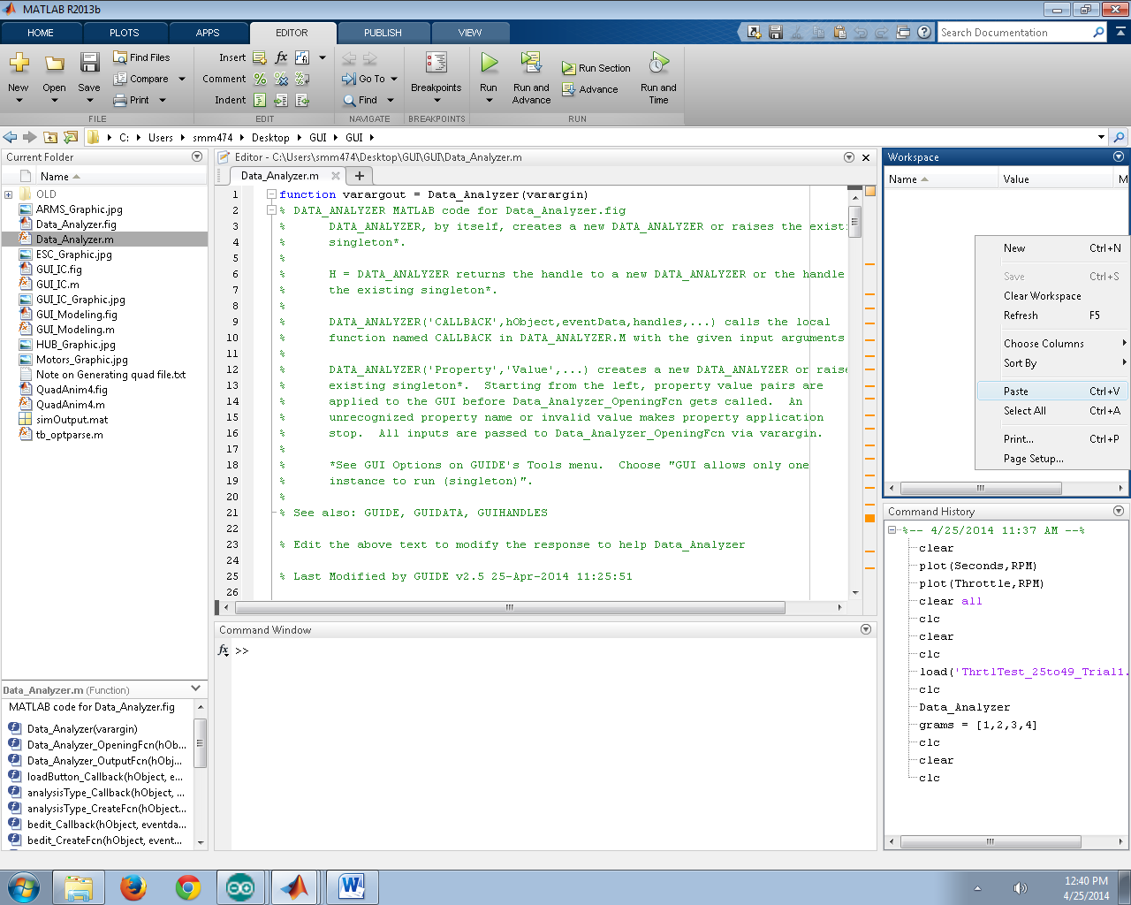

Figure 6: Pasting data into the MATLAB workspace

Step 3: The “Import” window will open, as seen below in Figure9. MATLAB is able to automatically populate the column headings as well (if not, columns must be labeled “Seconds”, “Throttle”, and “RPM” ). Select the green checkbox “Import Selection” at the top right of the Import window and MATLAB will import and parse the data (Figure10).

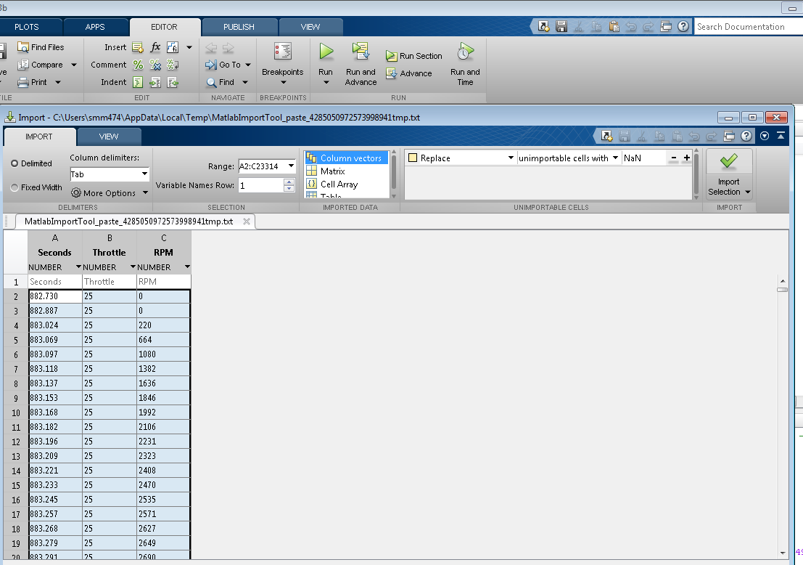
Figure7. Importing the selection into the workspace
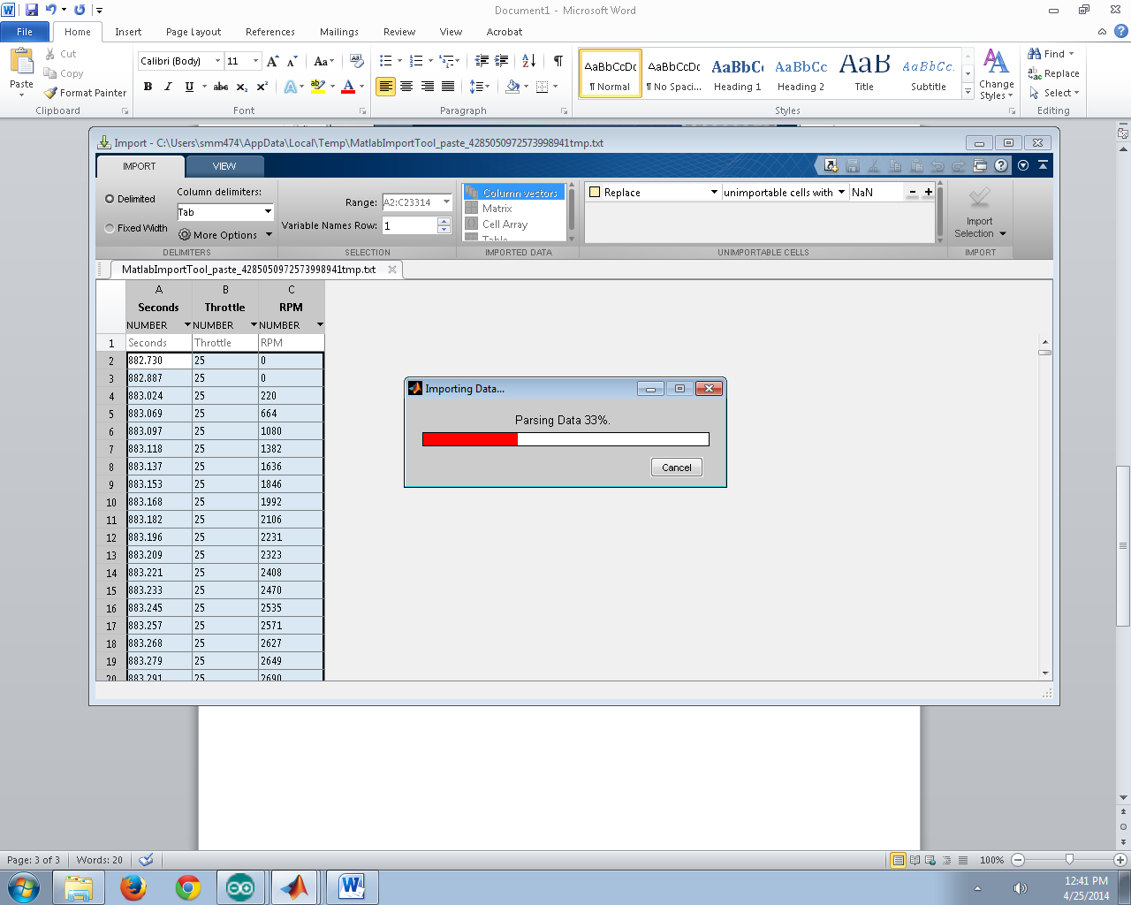
Figure8. Parsing the data

The data is now imported to the MATLAB workspace (Figure 9) as individual column vectors.
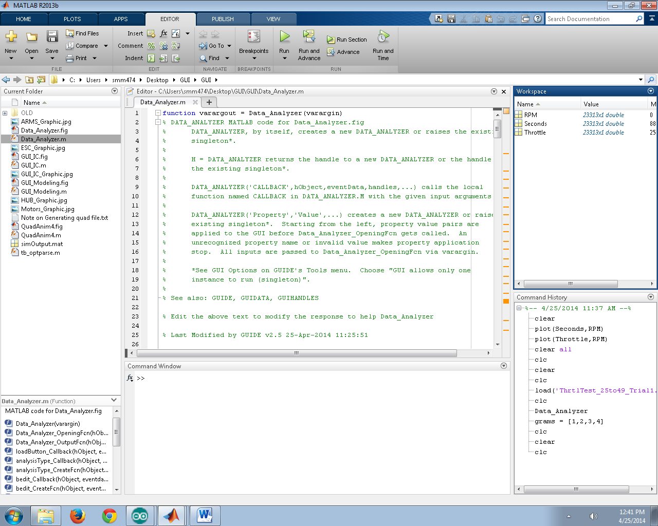
Figure 9. Data imported to workspace
Step 4: Copy raw scale measurements from an Excel sheet, as seen below in 10. If Excel was not used, you can manually enter a column vector of measurements.
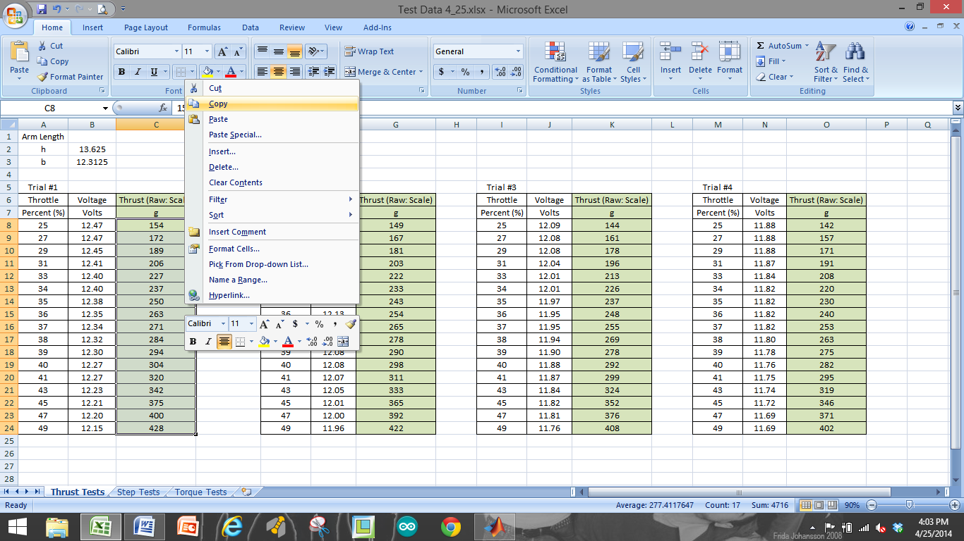

Figure 10. Copying data from Excel sheet

Step 5: This data from Excel can now be pasted into the MATLAB workspace along with the data from the Arduino COM window. This can be seen in Figure11.
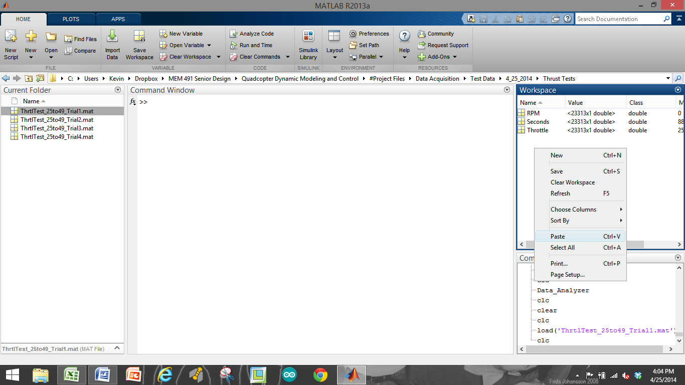
Figure11. Pasting data into workspace
Step 6: This step is important, as the analysis tools we provide require that the measurements from the scale be stored as a vector with a specific name. After selecting “Paste” into the workspace, MATLAB’s Import window will once again open, except that MATLAB now doesn’t know what to call the column heading. For this case, we must call the column heading “gramsMeas”. Once the heading is labeled, you can select “Import Selection” at the top right of the screen and MATLAB will import this data from Excel into a vector called “gramsMeas”. This is seen below in Figure12.
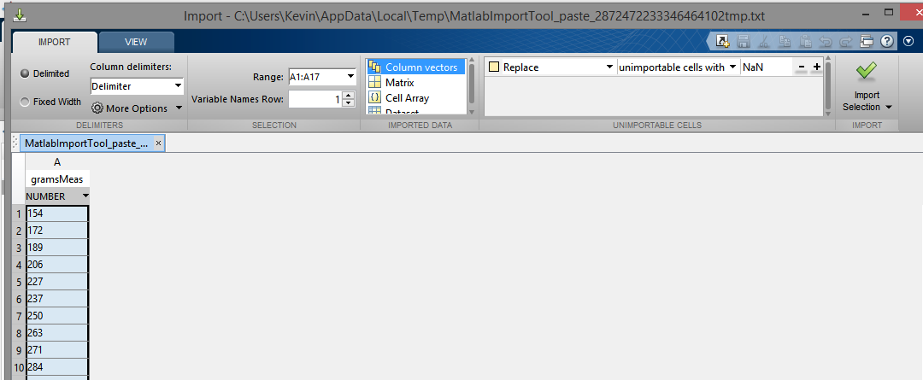
Figure12. Importing the data into vector called "gramsMeas"
Step 7: Finally, we are able to save all of this workspace data as a .mat file into a location of our choice for later use in the data analysis programs. Select all (4) variables in the workspace window, right click, “Save As…” and Save the data into the desired folder with a meaningful name (date, tests performed, variables of interest, etc.). See Figure13below.
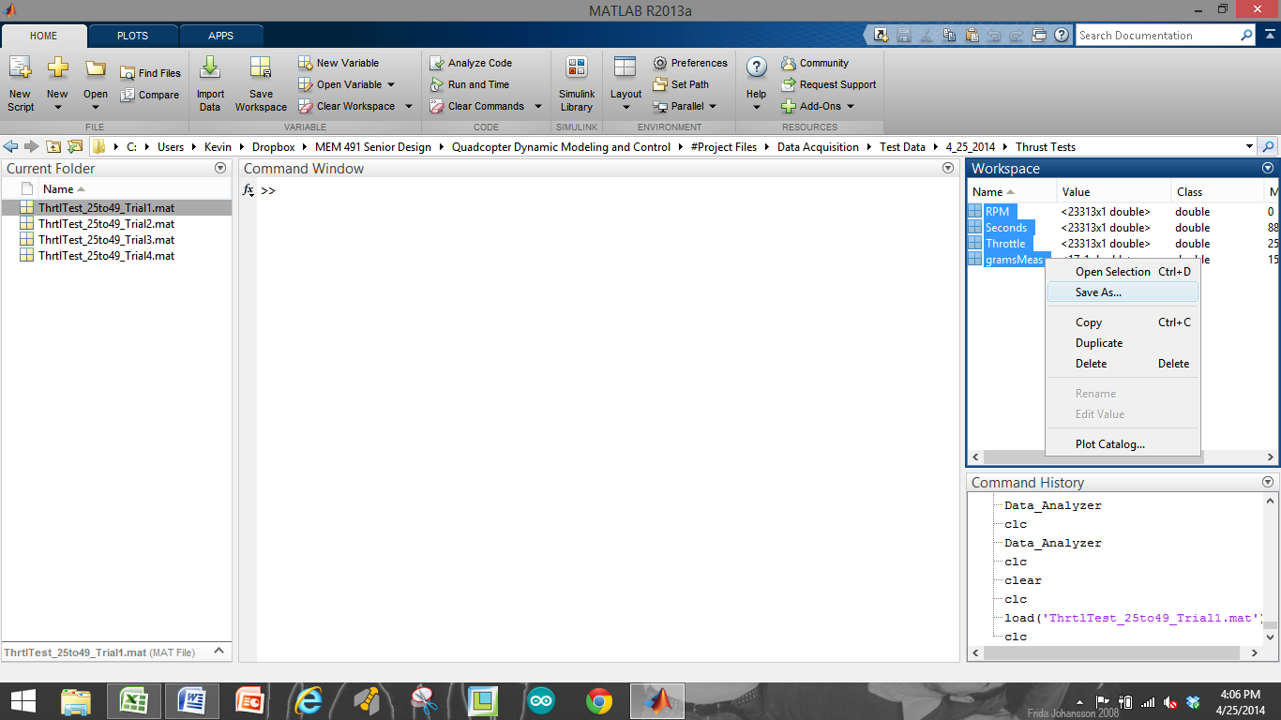
Figure13. Saving the data

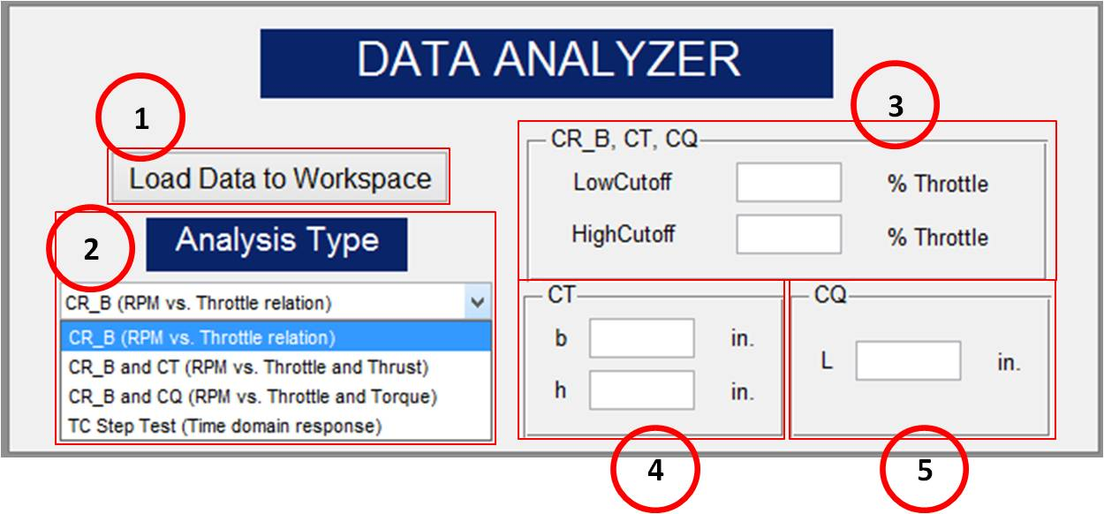
3.2 DATA ANALYZER

Figure.14. Data Analysis Program

The simulation requires us to estimate several quadcopter performance parameters that are acquired through experimental testing of the motors of the quadcopter vehicle. This GUI was made to help analyze this motor test data. The parameters this GUI is able to calculate are called: CR and b (Throttle to RPM conversion), CT (Thrust coefficient), CQ (Torque coefficient), and TC (motor time constant). By loading test data into the workspace the GUI can automatically calculate parameters and plot the data. The Data Analysis GUI can be seen in Figure14.

Description:
- Load button: this button loads in structures of data that were previously saved. The data loaded should correspond to the analysis to be performed (i.e. don’t try to use the TC Step Test analysis on Throttle Response Data!)
- Analysis Type – there are 4 options accessible through the drop down box:
  - CR_B (RPM vs. Throttle relation)
Required User Input:  Optional User Input: | Seconds, Throttle, and RPM data  Low Cutoff, High Cutoff
    - This type of analysis requires experimental data input of Seconds, Throttle, and RPM. It is the most general type of analysis this interface can perform. No raw scale readings of thrust or torque are needed. Once the “Run” button is selected, the program will analyze the RPM vs. Throttle data to obtain a fit that calculates the $C_{R}$ and $b$ parameters (linear relation with non-zero intercept between throttle percentage and RPM).
    - The LowCutoff and HighCutoff for throttle percentage can also be included in this program. These values are entered as shown on figure 1 above. For example, if a test is run between throttle limits of 0 and 60%, you may still only want the program to analyze the data between values of 20 and 40% throttle. This is an important concept since having the fit be accurate around the anticipated normal operating range is often more important that having the fit be based on the full possible range of RPM values. Therefore, we recommend some iteration involving finding the approximate throttle required for hover and then performing additional testing and parameter fits around this range (+/- 5-10% throttle for example). This will produce more accurate simulation results, and presumably better control design, at near hover conditions, which are usually the conditions of primary interest. If these values aren’t entered, the program will automatically find the lowest (non-zero) and highest throttle values from the test data and use those instead.
    - See the function “calculate_CR_B.m” for more details. It is strongly recommended that users spend some time understanding the function since the approach utilized might not be ideal for all users.
  - CR_B and C_{T} (RPM vs. Throttle and Thrust)
Required User Input:  Optional User Input: | Seconds, Throttle, and RPM data  gramsMeas (raw scale), b, h  Low Cutoff, High Cutoff
    - This type of analysis requires data inputs of Seconds, Throttle, RPM, and grams measured (gramsMeas: raw scale readings from thrust test). The analysis also requires inputs for the dimensions of the thrust test rig, namely: b and h. “b” is the distance from the pin joint on the rig to the point of contact with the scale. “h” is the height of the center motor axis above the pin joint on the rig.
    - NOTE: If the “Load Data to Workspace” button is used but the only data saved is Seconds, Throttle, and RPM, the gramsMeas (raw scale Thrust values) parameter must be added by another means, such as direct vector entry at the MATLAB command window or copy paste and import from a spreadsheet.
    - As with the CRΔB analysis, this type of analysis will also accept user inputs of low and high cutoff for Throttle %. See discussion above.
    - Once the data is loaded and the user inputs filled in, this program once again calculates the $C_{R}$ and $b$ parameters along with the $C_{T}$ coefficient (Thrust coefficient). $C_{T}$ is a relation between Thrust and RPM2.
    - See the function “calculate_CT.m” for more details. It is strongly recommended that users spend some time understanding the function since the approach utilized might not be ideal for all users.
  - CR_B and C_{Q} (RPM vs. Throttle and Torque)
Required User Input:  Optional User Input: | Seconds, Throttle, and RPM data  gramsMeas (raw scale), L  Low Cutoff, High Cutoff
    - This type of analysis requires data inputs of Seconds, Throttle, RPM, and grams measured (gramsMeas: raw scale readings from torque test). The analysis also requires an input for a Torque rig dimension, L. “L” is the perpendicular distance between the axis of the motor and the axis of the arm that is in contact with the scale.
    - NOTE: If the “Load Data to Workspace” button is used but the only data saved is Seconds, Throttle, and RPM, the gramsMeas (raw scale force values in grams) parameter must be added by another means, such as direct vector entry at the MATLAB command window.
    - As with the $C_{R}$ and $b$ analysis, this type of analysis will also accept user inputs of low and high cutoffs for Throttle %.
    - Once the data is loaded and the user input filled in, this program once again calculates the $C_{R}$ and $b$ parameters along with the $C_{Q}$ coefficient (Torque coefficient). $C_{Q}$ is a relation between Torque and RPM2.
    - See the function “calculate_CQ.m” for more details. It is strongly recommended that users spend some time understanding the function since the approach utilized might not be ideal for all users.
  - TC Step Test (Time domain response)
Required User Input:  Optional User Input: | Seconds, Throttle, and RPM data  N/A
    - This type of analysis requires data inputs of Seconds, Throttle, and RPM. The program calculates the time constant ($TC$) of the motor from a step change in throttle input.
    - The program does not utilize the low and high cutoffs for Throttle %, because it automatically recognizes the two throttle settings that the step command is operating between.
    - See the function “calculate_TC.m” for more details. It is strongly recommended that users spend some time understanding the function since the approach utilized might not be ideal for all users.

- Modeling GUI

4.1 Purpose
This GUI accepts user input of physical measurements from their quadcopter vehicle. A primary purpose of this interface is to calculate the moment of inertia matrix for the vehicle based on specific dimensions and measurements of the quadcopter. The interface also accepts the performance coefficients and other parameters obtained through motor testing. Once all of the fields are populated, the interface saves a MATLAB “structure” that contains all the parameters required to run the simulation. A structure is a data type that gives us a way to combine multiple pieces of information into a single variable that can easily be passed around the MATLAB environment. The modeling GUI can be seen below in Figure 5.
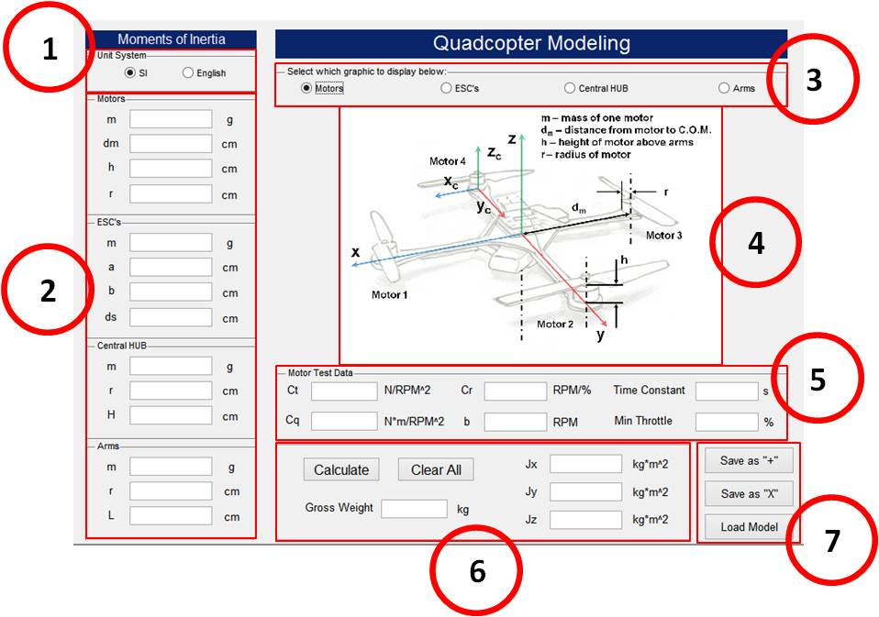
Figure 15. Modeling GUI

4.2 Description
- Unit System toggle: toggle units between SI and English based on the measurement tools being utilized. IMPORTANT: Whether inputs are in grams/centimeters or ounces/inches, the program will convert everything into the SI unit system (kilograms/meters) for use in the simulation.
- Inputs for Motor, ESC, HUB, and Arm dimensions (either in g/cm or oz./in.).
  - Motors:
    - m: mass of 1 motor (with propeller) using scale
    - dm: distance from the center of mass (COM) of the motor to the COM of the quad vehicle (COM is assumed to coincide with geometric center!)
    - h: height of the motor above the arm (not including prop axel)
    - r: radius of a motor
  - ESC’s:
    - m: mass of 1 ESC
    - a: width of an ESC
    - b: length of an ESC
    - ds: distance from the COM of the ESC to the COM the quad vehicle
  - Central HUB:
    - m: total mass of the central HUB (including battery, controller, power distribution board, etc.). This value might be most easily obtained by subtracting the mass of the individual components mentioned herein by the total weight of the quad in a “ready-to-fly” state (i.e. Hub mass = Total mass – (Motors + ESC’s + Arms).
    - r: radius of the central HUB (modeled as a cylinder, estimate as needed)
    - H: height of the central hub (total height, modeled as a cylinder, see Hub diagram)

  - Arms:
    - m: mass of (1) arm (motor, ESC, etc. excluded)
    - r: radius of an arm (modeled as a cylindrical rod)
    - L: length of an arm (arm only up to attachment to HUB)
- Toggle between graphics to display in center of GUI to assist in measuring parameters.
- Motor, ESC, HUB, and Arm graphics displayed in center of GUI
- Motor Test Data inputs: Coefficients obtained from motor test data are entered here. Also, “Min Throttle” (the minimum throttle setting for which actual motor rotation is achieved) can be entered. If this value is not known, simply enter “0”.
- Select the “Calculate” button to calculate the Gross Weight of the vehicle, and the Jx, Jy, and Jz values of the inertia matrix. Or, select “Clear All” to clear all of the GUI fields.
- Once the fields are populated, the user can select “Save as +” or “Save as X” to save the model in a “plus” configuration or in an “X” configuration. The parameters are saved inside a MATLAB “structure” from which the Simulink simulation extracts them during simulation. If a model is already saved, the user can select “Load Model” to select a desired structure and the GUI will populate the fields with these saved parameters. This is useful because if the user wishes to adjust 1 parameter of their model they don’t need to retype everything in again.

5. INTRODUCTION TO SIMULINK

5.1 Purpose
The Simulink based quadcopter simulation is intended to get you up and running with a simulation representative of your vehicle’s dynamic performance. We hope you will find the simulation to be understandable and to have a reasonableand intuitive layout. The simulation is intended to act as a sort of starter kit to help accelerate you towards the goals of your project and provide you with tools to explore quadcopter control design techniques. The simulation represents a synthesis of several author’s approaches to modeling the behavior of a quadcopter, with a little bit of additional modeling added by us. Many important effects (most obviously aerodynamic effects such as blade flapping) are ignored or dramatically simplified, so you will need to make sure you understand the limitations of the model in order to get reliable service out of it. Since it is written in Simulink and MATLAB code, we hope you will feel comfortable modifying or expanding the simulation in any way you desireto fit the needs of your project. To that end we’ve tried to provide understandable and adequately commented code and models to make modification by users a reasonable task.

5.2Required Skills/Knowledge
No special skills or knowledge are explicitly required to use this simulation, but for best results you’ll want a bit of the following:
- Experience in problem solving within the Simulink environment and running simulations
- Experience in problem solving within the MATLAB environment and writing scripts and functions
- A basic understanding of the mathematics associated with aircraft dynamics
- At leastsome familiarity with feedback control concepts (If’ you’ve never heard of PID control, you’ve got some serious studying to do) including both classical feedback control design and state-space modeling from a mathematics perspective. Really the more you know the more cool stuff you can do.
- Curiosity, patience, and determination. Seriously.

5.3Required Materials
- PC or Mac with MATLAB 2014a or later. May work on some earlier versions, but this is untested.
- If you want to simulate your own vehicle you will also need
  - A quadcopter model saved somewhere you can find it. (Normally this is saved from the Moment of Inertia GUI and should be a .mat file)

6. AC Quadcopter Simulation

- This is an attitude-command-only model. In other words, there is no control system to track position. Instead the controller only tries to track attitude ($ϕ,θ,ψ$and altitude (Z) commands using a PID controller (that isn’t particularly well tunedeither). When you first open the model you should see something like this
(Figure1).

Figure 16. AC Simulation Block

- Read over what all the blocks say they do. Notice the grey blocks; these are buttons. Double clicking on any of these will do what the button says. (These blocks are empty subsystems with their “OpenFcn” set to execute code, making them act like buttons)
- Double click the LOAD button and load an initial condition (IC structure), such as “Hover.mat”. Double click the button again and load a quadcopter model (quadModel structure), such as “quadModel_+”. Note that these structures now appear in the MATLAB workspace and can be interacted with or changed just like any MATLAB structure.
- With these loaded the simulation can be run, but let’s check out a few things first. Open the Attitude Commands block and look at the signal source blocks. These can be changed to anysource you want, and what we’ve provided is just an example. Note that the simulation uses radians for angles and meters for distance except where otherwise noted (many interfaces and plots do a conversion internally and will have different units labeled). Next check out the Attitude Controller block. Looking in here you’ll see the following (17).

Figure17. Attitude control block interior

- The text on the front of these blocks is changed to reflect the mask parameter values. Click on one of the blocks and look at the interface for changing the PID gains. If you want to look at the PID control signal path inside, either click the little arrow in the bottom left corner of the block or right click and select (“Mask-Look under mask”).Notice anything unusual about the PID controller?

- When you’ve explored that, back out and look inside the next block entitled “Quadcopter Control Mixing.” This block takes the correction commands for the Phi, Theta, Psi and Z and “mixes” them by letting each correction be sent to the correct motor. It should say “Configuration “+”” on the front, indicating that it has recognized that you loaded a “+” configuration model. You should see something like this inside.
Figure.18. Quadcopter control mixing overview
- The purpose of the switch mechanism is to allow both “X”-configuration and “+”-configuration vehicles to be controlled correctly without having to use a different block. Take a look inside both the “+” and “X” blocks. The plus block is the one that will actually be used right now since we loaded a “+” quadcopter model. The equations are written next to each output for reference (see Figure 19).

Figure 19. Plus configuration control mixing

- It should be mentioned that these output signals are in terms of percent throttle. This is very important, as it allows us to tune the controller and expect the same performance from the simulated quadcopter for a given control system set of gains as we would get from a real-world quadcopter control system implementation (as long as the real implementation also computed response in terms of percent throttle, which is easy to achieve).

- Next we’ll check out the Quadcopter Dynamics block. Inside you’ll see the diagram shown in Figure20.
Figure 20. Quadcopter Dynamics block

- The motor dynamics block restricts input commands to between 0% and 100% throttle (which is obviously the maximum possible range of throttle command signals), simulates the motor cutoff behavior at very low throttle, and most importantly applies the $C_{R}$ and $b$ linear relation to the percent throttle signal and simulates the first order delay. The output of the block is the RPM for each motor at any given moment in time.

- The disturbance block is probably not something you’ll use very much. It was added in order to make it easier for you to add external disturbance effects (such as wind forces on the vehicle) to the simulation. Use it as a simple example, and develop it to suit your needs. Otherwise, just leave all the disturbance inputs as zero.

- Finally we have the heart of the simulation. The State Equations block executes a Level 2 S-Function written in the MATLAB language. This code can be viewed by clicking “edit” from the mask of the block (or opening the code file directly from MATLAB). This is where we simulate the state equations describing the dynamic behavior of the vehicle. Notice on the mask of the S-Function block that there are parameter inputs called “quadModel” and “IC”. This is where the structures from the workspace are passed to the S-function.

- Now, let’s run a simulation. If you have an “IC” and “quadModel” structure already loaded, try clicking the Simulink run button. We have used ode45 with the usual parameters set to “auto” will suffice (a fixed step solver may be preferable, but you can make that determination on your own).

Results
After the simulation runs (should only take a few seconds), you can take a look at the simulation output by clicking the OPEN PLOT button. You’ll get two figures that should be pretty self-explanatory. Notice that on the first plot, the attitude and altitude commands are shown with a dotted black line, while the response of the simulated behavior of the vehicle is shown with a blue, red, or green line.
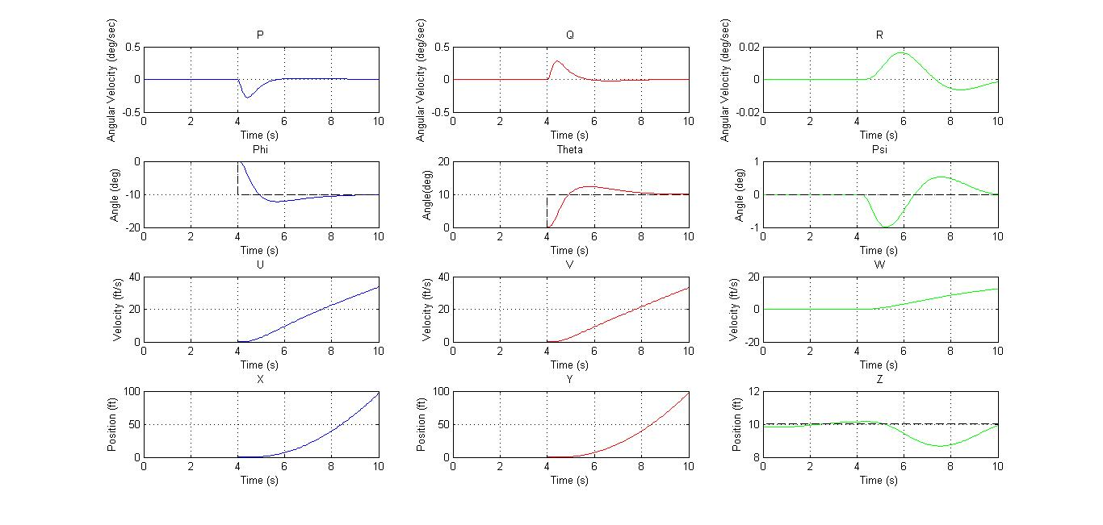
- First Plot

The second plot shows motor commands and motor speeds (in RPM).. Much of the simulation output data is saved in 'yout', and any additional values or variables you want to save can be added using what we’ve done as an example.
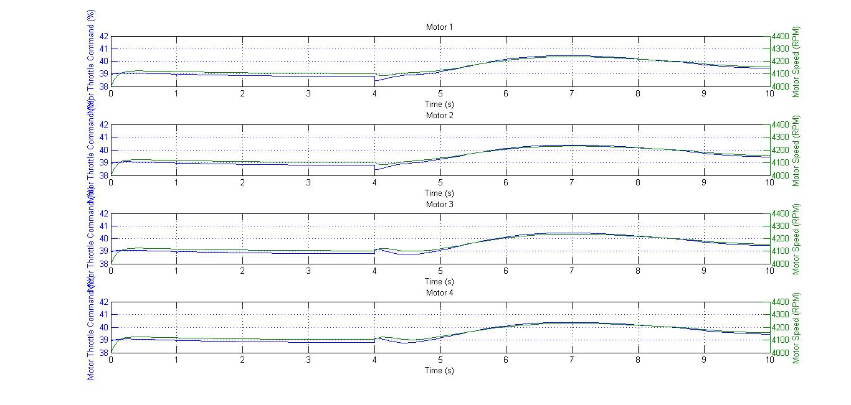
- Second Plot

It may be difficult to realize the Results with the help of the graphs mentioned above. Hence, we have developed an Animation GUI which gives a visual representation of the physical responses of the quadcopter from the simulated output data.
This GUI was developed to provide a more intuitive view of simulation output than can be offered by simple 2D graphs of aircraft Euler angles and states. It displays the quadcopter’s attitude relative to the inertial frame, and also displays the quadcopter’s position in the inertial frame. The animation is able to display the quadcopter in either the “X” or “+” configurations automatically depending on which quadcopter model (quadModel.mat) file is currently stored in the Workspace.
Click on OPEN GUI: Flight Animation.
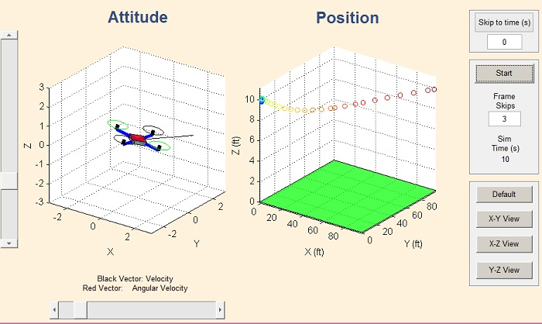
RESULT
Description:

1. Attitude: displays the vehicle’s attitude. Also displays arrows for the angular velocity (red) and the velocity (black) vectors.
2. Position: displays the position of the vehicle in the inertial frame. It plots the 3D trajectory of the quadcopter through each time step of the simulation. The path marker color is changed with time to give an additional element of time information.
3. Vertical slider: change the elevation viewing angle during the animation
4. Horizontal slider: change the azimuth viewing angle during the animation
5. Skip to Time: allows for the user to begin the animation from a specific time during the simulation, instead of always requiring the animation to start from t = 0s. Type in a time (seconds), click the button, and the animation is ready to start from that time. If this button isn’t used, the animation will default to starting at t = 0s.
6. Start button, Frame Skips button, and Simulation Time display: First, the user can select the Start button to begin the animation from whatever the “Skip to Time” value is entered (see note 5). The “Frame Skips” button is used to either speed up or slow down the animation by setting the step size to take for plotting. “0” plots every frame (every moment for which simulation state data exists), “1” plots every other frame by skipping one frame each plot, and so on.
7. Snap to View buttons: these buttons are used for setting specific viewing angles during the animation. Instead of attempting to drag the sliders to get a perfect viewing angle in a certain plane, these buttons allow for quickly setting different plane views, or the default viewing angle.

REFERENCES
- R. Mahony, V. Kumar, and P. Corke, “Multirotor Aerial Vehicles: Modeling, Estimation, and Control of a Quadrotor,” in IEEE Robotics and Automation Magazine, vol. 19, Sept. 2012, pp. 20-32
- P. I. Corke, Robotics, Vision & Control: Fundamental Algorithms in MATLAB. Berlin: Springer-Verlag, 2011.
- L. Ascorti, “An Application of the Extended Kalman Filter to the Attitude Control of A Quadrotor”, Politecnico Di Milano, 2013
- Rick. "Designing a Thrust Test Bench."Web log post.Confessions of a Quadcopter Addict.Blogspot, 04 Apr. 2013. Web. 1 Dec. 2013.
- <http://confessionsofaquadcopteraddict.blogspot.com/2013/04/designing-thrust-test-bench.html>.
- P.E. Pounds, "Design, Construction and Control of a Large Quadrotor Micro Air Vehicle," The Australian National University, Sept. 2007.
- MathWorks. Simulink: Simulation and Model-Based Design. Web. 14 Mar 2014.
- < http://www.mathworks.com/products/simulink/>.
- C. Jagadish and B. C. Chang, “Fault-tolerant attitude computation for unmanned aerial vehicles,” Transactions of the Institute of Measurement and Control
- T. Fisher, Online discrete filter coefficient calculator, <http://www.users.cs.york.ac.uk/~fisher/mkfilter/trad.html>>

